Specification Document Of

# Final Production Project

Submitted by: Sameer Basnet

Student Id: 77356702

BSc (Hons) Computing

## **Breaking the Slience: AI and Computer Vision Driven Sign Language Translation System**

**Project Aim:**

This project plans to use computer vision and AI to develop a sign language translation system which aims to aid deaf and mute individuals to interact with individuals in English language in mode of text or speech and text to speech. This product will be able to do that by translating their hand gestures into English language by using computer vision and AI technique’s.

**Objectives:**

The main objective of this project is to develop a product which:

* **To develop a real-time AI platform that accurately recognizes ASL hand gestures from live video and, conversely, converts user-entered English text—without requiring complex grammar analysis—into smooth ASL gesture videos.**
* **Translate recognizes hand gestures into English language for satisfactory communication.**
* **Simple User Interface (UI) that allows users to easily interact with the system and view output.**
* **Integrate Text-to-Speech (TTS) module into the product to convert output text to speech for enhance accessibility of the product for users.**
* **To improve the product robustness, a real-time error handling mechanism will be integrated that provides real time feedback when a gesture is not recognized or detected, ensuring a smooth and user-friendly experience.**

**Product Specification:**

The product specification is categorized into functional and non-functional requirements and is described below with MoSCoW method:

|  |  |
| --- | --- |
| **Functional Requirements** | **MoSCo W** |
| **Real- time gesture detection and recognition** | M |
| **Conversion of user-entered English text (no advanced grammar) into ASL gesture video** | M |
| **Translation of recognized gesture into English text** | M |
| **Integration of hand detection and recognition models** | M |
| **User Friendly UI for user to use the product** | M |
| **Integration of Text-to-Speech (TTS) module** | S |
| **Real time Error Handling System in case of gesture not recognized or detected** | S |
| **Integration with mobile platform for portability** | C |
| **AR/VR integration** | W |
| **Complex Dynamic Sign Language Grammar Support** | W |
| **Multi-User real time collaboration for gesture translation.** | W |

|  |  |
| --- | --- |
| **Non-Functional Requirements** | **MoSCo W** |
| **Product Accuracy in gesture recognition** | M |
| **Product is tested and validated** | M |
| **Product is user friendly** | S |
| **Product shall be platform independent** | C |
| **Product must maintain stable and consistent performance in diverse conditions.** | **M** |
| **Product UI to be accessible for users with little technical knowledge.** | **S** |
| **Provide support for external Camera** | **C** |
| **Development on cloud platform for large-scale use.** | **W** |
| **Real time integration with AR/VR glasses** | **W** |

**Research:**

Sign language Detection (SLR) refer to the process of recognizing and explanning gestures, hand movements and body language used in sign language to hold communication between people who use sign language and who do not. The field of SLR has witnessed outspoken improvements over years, staring from neural network-based systems to deep learning based systems. Early examined two stage neural network that uses a DataGlove for phoneme-level recognition, achieving 86% accuracy but was restrained by hardware depandance work (Kim, S. et. al., 1995). Another research used self-organizing frameworks like SHOSLIF-M, improving spatiotemporal recognition with a 96% accuracy rate. However, its reliance on custom-built features and limited scalability to real-life scenarios laid challenges (Cui, Y. et. al., 1995). Another Research focus on static, isolated, single-handed signs using camera-based systems, featuring a lack of organized datasets and a need for dynamic sign recognition improvements (Wadhawan, A. et. al., 2021). The use of CNNs showed odd performance with 99.90% accuracy for static signs using extensive datasets, highlighting the strength of deep learning (Kumar, P. et. al., 2020). Use of statistical methods for nonstop sign language handle real-life variability, placing multimodal features like facial landmarks and achieving revealing word error rate reductions (Koller, O. et. al., 2015). Another Study used statistical methods and fenones for efficient sign recognition but strumbled with sturdy subunit definition for varied gestures (Bauer, B. et. al., 2002). Another studyimproved a real-time sign language interpreter using a data glove and HMMs but met challenges with endored dependency and limited accuracy (Ouhyoung, M. et. al., 1998).

**Evaluation:**

This assessment of the Sign Language Recognition System will focus on its foremost and extended functionalities as defined in the product specifications and objectives. Firstly, every component will be tested separately, including hand detection, gesture recognition, and text-to-speech integration, focused on their speed of response, accuracy, and trustability. Afterwards, the whole workflow will be relied for real-time capability and system response time. The judgement process will relate to both quantitative metrics (such as recognition accuracy, response time, and error rates) and qualitative feedback (like user opinions on the system’s usability). Furthermore, the system will experience testing in different situations, seeing factors such as varying lighting conditions, hand sizes, and positions, to validate its robustness and scalability.

**Project Planning and Methodology:**

After research, the project will get going by choosing a fit dataset for gesture recognition, which could include the ASL dataset or a newly created dataset comprising both static and dynamic signs. Already trained hand tracking models, such as Mediapipe, as well as TensorFlow or PyTorch models for gesture detection, will be used. The research will follow a flexible strategy, starting with an assessment of the performance of every model in tasks such as hand detection and gesture classification. These models will be integrated into a pipeline designed to recognize gestures in real time. Metrics such as accuracy, latency, and robustness in varying conditions will be measured for every component primarily to being used within the entire application. The Agile methodology will be used as continuous testing and development will be required in this type of application. The planning process will be shown using a project timeline and Gantt chart to assure clear milestones and efficient time management.

**Project Timeline:**

Fig: *The above Project Timeline shows the project planning along with the dates.*

**Gantt Chart:**

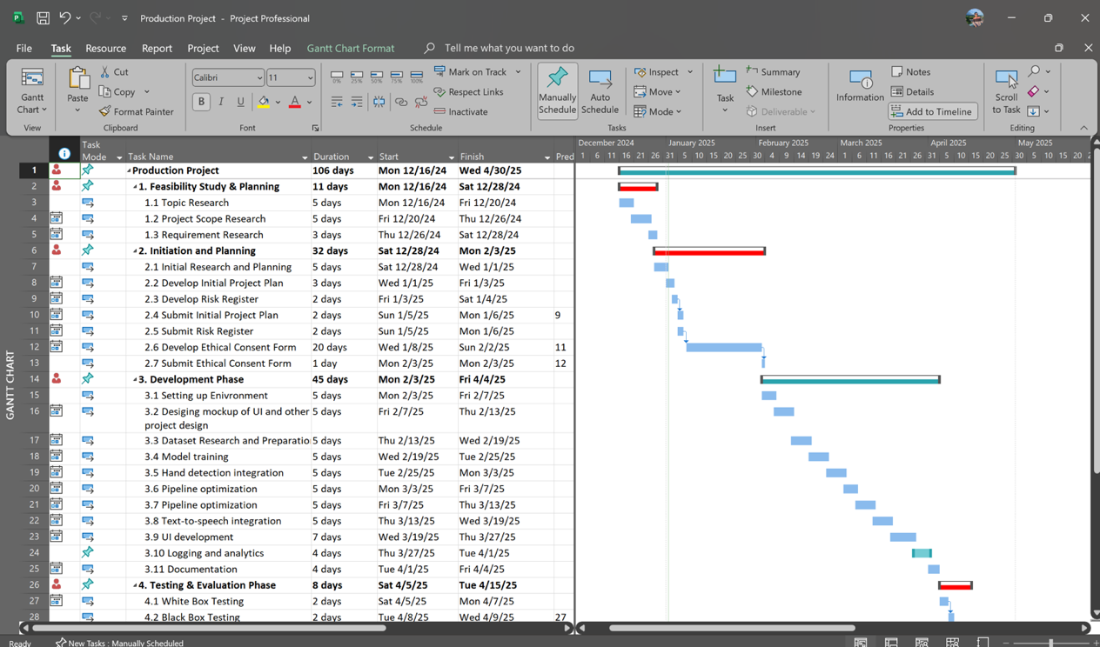

Fig: *The above Gantt chart shows the project planning along with the key dates.*

**Resources:**

The list of resources (hardware and software) is listed below. All the software is free open-source products and can be easily downloaded online.

**List of Software:**

* Python
* PyCharm
* OpenCv
* Mediapipe
* MS Word
* MS Powerpoint
* MS Project
* MS Excel
* TensorFlow/Keras
* PyTorch
* Scikit-learn
* Pandas
* NumPy
* pyttsx3
* Matplotlib
* Seaborn
* TensorFlow Lite
* PyInstaller
* Tkinter
* HTML
* CSS
* JavaScript
* PHP
* Django
* Convolutional Neural Networks (CNNs)
* Recurrent Neural Networks (RNNs)
* **Transformers**
* Hidden Markov Models (HMMs)
* Discord
* Draw.io
* Google Drive
* Github
* Google doc
* Google Slide
* Google Sheets
* Gmail
* Google Scholar
* Google Meet
* Microsoft Team
* ANL Dataset

|  |  |
| --- | --- |
| **List of Hardware:**   * MacBook Air M1 13 inch * External Webcam |  |

**Bibliography:**

* ***Bauer, B., Swets, D.L., Weng, J.J. Friedrich, K.K., (2002) Towards an Automatic Sign Language Recognition System Using Subunits. Springer Nature Link. [Online]. 2298, Available from: <https://link.springer.com/chapter/10.1007/3-540-47873-6_7> [Accessed 31 Dec 2024].***
* ***Cui, Y. , (1995) Learning-based hand sign recognition using SHOSLIF-M. IEEE. [Online]. 0 (10.1109/ICCV.1995.466879), pp. 0. Available from: <https://ieeexplore.ieee.org/abstract/document/466879> [Accessed 31 Dec 2024].***
* ***Kim, S., Waldrom, M.B. (1995) Isolated ASL sign recognition system for deaf persons. IEEE. [Online]. 3 (3), pp. 261 - 271. Available from: <https://ieeexplore.ieee.org/abstract/document/413199> [Accessed 31 Dec 2024].***
* ***Koller, O. (2015) Continuous sign language recognition: Towards large vocabulary statistical recognition systems handling multiple signers. Computer Vision and Image Understanding. [Online]. 141, pp. 108-125. Available from: <https://www.sciencedirect.com/science/article/abs/pii/S1077314215002088> [Accessed 31 Dec 2024].***
* ***Kumar, P. Wadhawan, A****.****(2020) Deep learning-based sign language recognition system for static signs. S.I. : Hybrid Artificial Intelligence and Machine Learning Tech. [Online]. 32 , pp. 7957–7968. Available from: <https://link.springer.com/article/10.1007/s00521-019-04691-y#citeas> [Accessed 31 Dec 2024].***
* ***Ouhyoung, M., Ling, R.H., (1998) A real-time continuous gesture recognition system for sign language. IEEE. [Online]. pp. 10.1109/AFGR.1998.671007. Available from: <https://ieeexplore.ieee.org/abstract/document/671007/authors#citations> [Accessed 31 Dec 2024].***
* ***Wadhawan, A., Kumar, P. (2019) Sign Language Recognition Systems: A Decade Systematic Literature Review. Springer Nature Link. [Online]. 28 , pp. 785–813. Available from: <https://link.springer.com/article/10.1007/s11831-019-09384-2> [Accessed 31 Dec 2024].***